Infrastructure Investments
Rosewood Area Water System Improvements (WM3925)

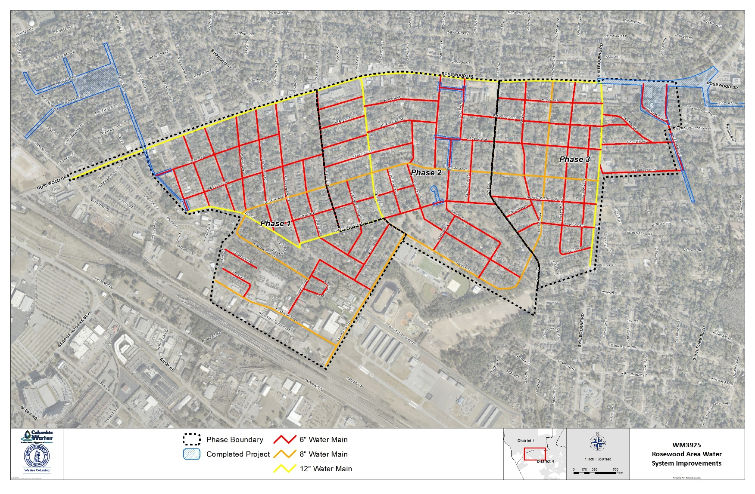
Construction of approximately 115,500 linear feet of 12-inch, 8-inch and 6-inch water mains along various roads in the Rosewood Neighborhood over the course of three phases.
S Kilbourne Rd
Phs 1
Phs 2
Phs 3
S Ott Rd
S Maple St
Rosewood
Schedule:  Phase 1 Construction Start Date: Fall 2023  Phase 1 Construction Completion: Spring 2025  Phase 2 Construction Start Date: Spring 2024*  Phase 2 Construction Completion: Fall of 2026*  Phase 3 Construction Start Date: Fall 2024**  Phase 3 Construction Completion: Spring 2027**  *Pending permitting and material availability  **Pending funding and material availability | Approximate Cost: $12 Million – Phase 1  $10 Million – Phase 2  $12 Million – Phase 3  For More Information:  Aaron Marshall, PE, Senior Civil Engineer  Email: Aaron.Marshall@ColumbiaSC.gov  Phone: 803-545-3265

Rosewood Area Water System Improvements
Public Information Meeting
September 14, 2023 6:00pm
Edisto Discovery Park

Welcome Columbia Water
Project Overview Travis Basnett, Hussey Gay Bell
Construction Expectation Ted Blackwell, LAD Construction
Questions & Answer Session All Stakeholders

Key Project Contact Information

Aaron Marshall, PE
Senior Civil Engineer, Columbia Water
803.545.3265 | Aaron.Marshall@ColumbiaSC.gov

Matt Blackwell
Construction Inspector, City of Columbia
803.216.4590| Matthew.Blackwell@ColumbiaSC.gov

