Columbia Canal Recovery Update – October 4, 2024

Canal Headgate Repairs
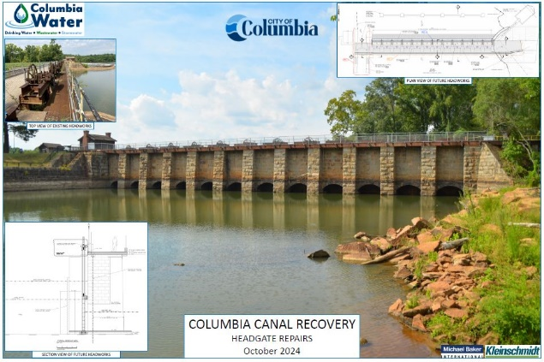
- Project Description: Removal of temporary bulk heads and replacement of twelve existing headgates, installation of rock anchors for structural stability and deployment of a track rack for debris removal.
- Cost Estimate and Funding: Construction cost of approximately $12M, with $5.6M of available funding through HUD CDBG Mitigation grant.
- Schedule: Construction 15 months, beginning August 2025

Embankment Repairs

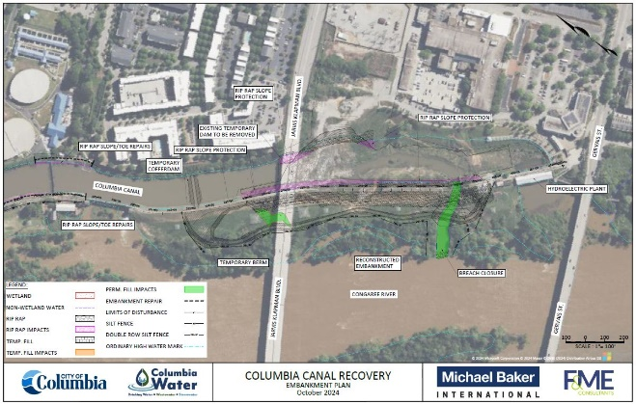
- Project Description: Removal of existing embankment and reconstruction of breach area, repair of damage to embankment toe and slope, renovation of hydroelectric generating station, repair of Riverfront Park facilities and documentation of historical features.
- Cost Estimate and Funding: Construction cost of approximately $60M, with funding provided through FEMA Public Assistance Program and State allocated resources.
- Schedule: Construction 27 months, beginning August 2025

Resilient Water Supply
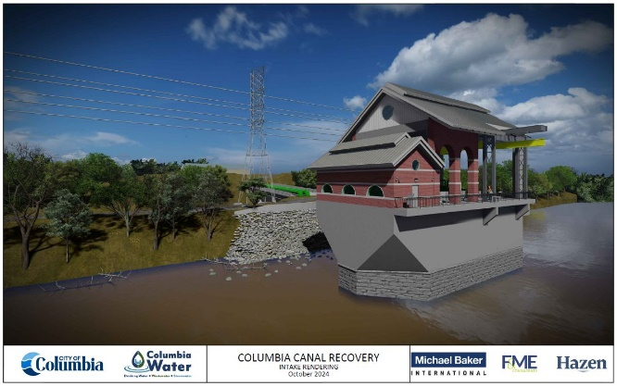
- Project Description: Installation of water supply intake in the Congaree River, providing up to 80 million gallons per day of supply and pumping capacity, minimizing reliance on the Canal and improving water system resilience.
- Cost Estimate and Funding: Construction cost of approximately $46.6M, with $32.6M of available funding through FEMA Building Resilient Infrastructure and Communities grant.
- Schedule: Construction 30 months,
beginning December 2024

