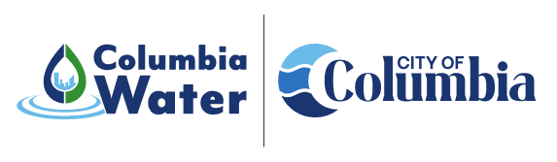
Canal Recovery
Projects
Resilient Water Supply Project
Project Description: | 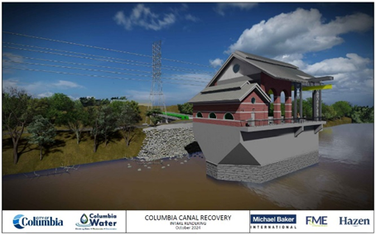  Installation of a new water supply intake directly from the Congaree River, directly adjacent and on the river side of the existing Columbia Canal embankment. Project components consist of submerged intake screens, concrete wet well, submersible pumps, electrical controls and equipment, stand-by generator, piping, valves and appurtenances. A bridge will be constructed to support access to the intake and source water piping to deliver water from the river to the Canal Water Treatment Plant. The intake will have a design capacity of 80 million gallons per day and will provide redundancy in the event of an issue with the existing intake or Canal system.
Objectives: | To increase water supply resiliency for the Columbia Canal Water Treatment Plant through construction of an independent, alternate water supply intake directly in the Congaree River, thus reducing reliance on the current water supply intake and existing Canal system.
Project Type: | 2015 Flood Recovery – Drinking Water Source
Council District: | System-wide generally
Project Funding: | This project is being funded through a combination of the City’s capital improvement program and a $32.5M resilience grant from the Federal Emergency Management Agency. The construction cost is approximately $62M.
Current  Project Status: | The notice to proceed for construction was issued in January 2025 with a projected duration of 30 months.
Project Contacts: | Gregory Tucker  Special Projects Manager  803.545.4309 | Gregory.tucker@columbiasc.gov  Benjamin Wildt  Columbia Water Communications Manager  803.545.0466 | blwildt@columbiasc.gov

